Introduction to Control Statements
The Control Flow Statements in C# are the statements that Alter the Flow of Program Execution and provide better control to the programmer on the flow of execution. The Control Flow Statements are useful to write better and more complex programs. A program executes from top to bottom except when we use control statements. We can control the order of execution of the program, based on logic and values.
Generally, the statements inside our C# program are executed from top to bottom, in the order that they appear. The Control flow statements, change or break the flow of execution by implementing decision-making, looping, and branching in our program to execute particular blocks of code based on the conditions.
Types of Control Flow Statements in C#:
In C#, the control flow statements are divided into the following three categories:
- Selection Statements or Branching Statements: (Examples: if-else, switch case, nested if-else, if-else ladder)
- Iteration Statements or Looping Statements: (Examples: while loop, do-while loop, for-loop, and foreach loop)
- Jumping Statements: (Examples: break, continue, return, goto)

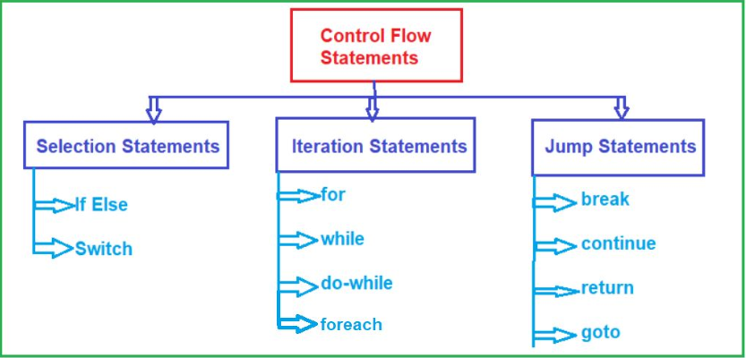
Note: The Control Flow Statements are used to write powerful programs by repeating important sections of the program and selecting between optional sections of a program.
Selection Or Branching Statements:
It is also called as Decision Making Statements. Decision Making in a programming language is very much similar to decision-making in real life. For example, you might have one situation where you will decide whether you to go to the office or you want to go theatre to watch a movie. And the condition is that, if it is raining, I will go to the theatre and if it is not raining then I will go to the office. So, the condition is rain, and based on the rain, you will decide what you need to do.
In programming also, we will face some situations where we want a certain block of code to be executed when some condition is fulfilled. The decision-making statements in C# allow us to make a decision, based upon the result of a condition. If the condition is satisfying, we may need to execute some piece of code and if the condition is failed, we might need to execute some other piece of code.
The Selection or Branching or Decision-Making Statements in C# allows us to control the flow of program execution based on some condition. It executes different sections of code depending on a specific condition. Selection statements can be divided into the following categories:
- If-Else Statements
- Switch Statements
If Statement
It executes a block of statements (one or more instructions) when the condition in the if block is true and when the condition is false, it will skip the execution of the if block. Using else block is optional in C#.
if(condition){
Statement;
}
If Statement without Curly Braces in C# Language
In the declaration of if block if we do not specify statements using blocks {} (curly braces), then only the first statement will be considered as the if block statement.
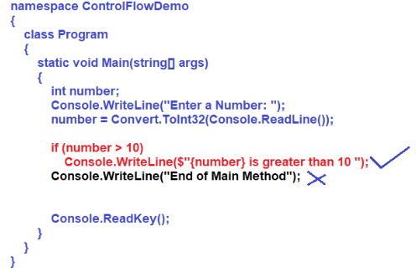

If Else Statements in C# Language:
The If-Else block in C# Language is used to provide some optional information whenever the given condition is FALSE in the if block. That means if the condition is true, then the if block statements will be executed, and if the condition is false, then the else block statement will execute.
So, in simple words, we can say that, if we want to execute some statement(s) when the condition is true and we also want to execute some other statement(s) when the condition is false, then, in that case, we need to use IF-ELSE conditional statements in C#.
if(condition){
If statements;
}
else{
Else statements;
}

If and Else Block without Curly Braces in C# Programming Language
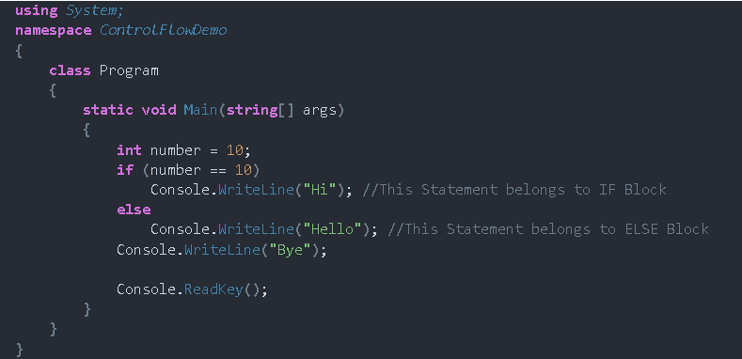

Nested If-Else Statements in C# Language:
When an if-else statement is present inside the body of another if or else then this is called nested if-else. Nested IF-ELSE statements are used when we want to check for a condition only when the previous dependent condition is true or false.
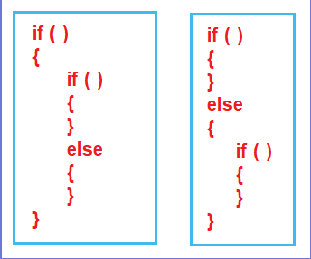

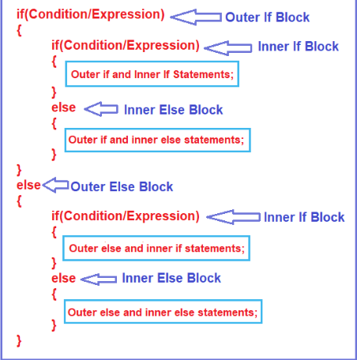

If-Else Ladder
using System;
namespace ControlFlowDemo
{
class Program
{
static void Main(string[] args)
{
int i = 20;
if (i == 10)
{
Console.WriteLine("i is 10");
}
else if (i == 15)
{
Console.WriteLine("i is 15");
}
else if (i == 20)
{
Console.WriteLine("i is 20");
}
else
{
Console.WriteLine("i is not present");
}

Console.ReadKey();
}
}
}

Switch Statements in C# Language:
The switch is a keyword in the C# language, and by using this switch keyword we can create selection statements with multiple blocks. And the Multiple blocks can be constructed by using the case keyword.
Switch case statements in C# are a substitute for long if else statements that compare a variable or expression to several values. The switch statement is a multi-way branching statement which means it provides an easy way to switch the execution to different parts of code based on the value of the expression.
Syntax:
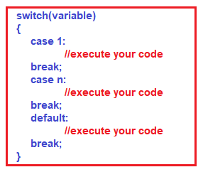

Note: After the end of each case block, it is necessary to insert a break statement. If we are not inserting the break statement, then we will get a compilation error. But you can combine multiple case blocks with a single break statement if and only if the previous case statement does not have any code block.
Example:
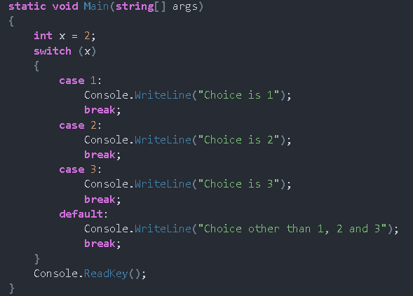

Nested Switch Statement in C#:
Whenever we create a switch statement inside another switch statement, then it is said to be a nested switch statement and this is allowed in C#.
using System;
namespace ControlFlowDemo
{
class Program
{
static void Main(string[] args)
{
//Ask the user to enter a number between 1 and 3
Console.Write("Enter a Number Between 1 and 3:");
int number = Convert.ToInt32(Console.ReadLine());

//outer Switch Statement
switch (number)
{
case 1:
Console.WriteLine("You Entered One");
//Ask the user to enter the character R, B, or G
Console.Write("Enter Color Code (R/G/B): ");
char color = Convert.ToChar(Console.ReadLine());

//Inner Switch Statement
switch (Char.ToUpper(color))
{
case 'R':
Console.WriteLine("You have Selected Red Color");
break;
case 'G':
Console.WriteLine("You have Selected Green Color");
break;
case 'B':
Console.WriteLine("You have Selected Blue Color");
break;
default:
Console.WriteLine($"You Have Enter Invalid Color Code: {Char.ToUpper(color)}");
break;
}
break;

case 2:
Console.WriteLine("You Entered Two");
break;

case 3:
Console.WriteLine("You Entered Three");
break;
default:
Console.WriteLine("Invalid Number");
break;
}

Console.ReadLine();
}
}
}
Loops in C#:
Loops are also called repeating statements or iterative statements. Loops play an important role in programming. The Looping Statements are also called Iteration Statements.
The process of repeatedly executing a statement or group of statements until the condition is satisfied is called looping. In this case, when the condition becomes false the execution of the loops terminates. The way it repeats the execution of the statements or instructions will form a circle that’s why iteration statements are called loops.
There are two types of loops
- Counter Loops: Counter Loops are the loops, which execute a specific set of instructions a certain number of times. Example: Token system followed in hospitals where the whole intention could be getting the headcount of patients.
- Conditional Loops: Conditional Loops are the loops, which execute a specific task until the condition is true. Example: Attend the online classes until the covid-19 situation comes to control.
Types of Loops in C#
Iteration statements create loops in the program. It repeats the same code several times until a specified condition is satisfied. Iteration statements execute the same set of instructions until a termination condition is met. There are four types of looping statements in C#. They are as follows:
- For loop
- For Each Loop
- While loop
- Do while loop
While Loop :
A loop is nothing but executes a block of instructions or statements repeatedly as long as the loop condition is true. How many times it will repeat means as long as the given condition is true. When the condition fails, it will terminate the loop execution.

A while loop is used for executing a statement repeatedly until a given condition returns false. Here, statements may be a single statement or a block of statements. The loop iterates while the condition is true.
Syntax:
while(condition ){
Statements;
}
Example:
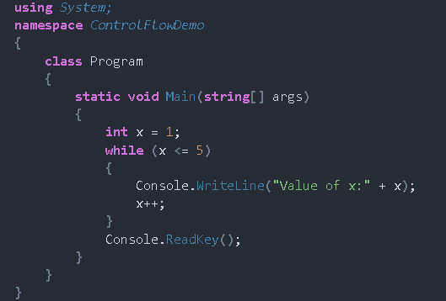

Nested While Loop
Writing a while loop inside another while loop is called nested while loop or you can say defining one while loop inside another while loop is called nested while loop. This is the reason why nested loops are also called “loops inside the loop”. There can be any number of loops inside one another with any of the three combinations depending on the complexity of the given problem. In implementation when we need to repeat the loop body itself n number of times then we need to go for nested loops.
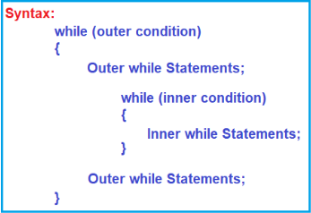

Do-While Loop
The do-while loop is a post-tested loop or exit-controlled loop i.e. first it will execute the loop body and then it will be going to test the condition. That means we need to use the do-while loop where we need to execute the loop body at least once.
Syntax:
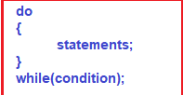
Nested Do-While Loop
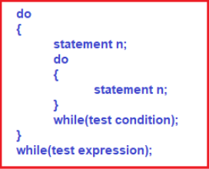
For Loop
For loop is one of the most commonly used loops in the C# language. If we know the number of times, we want to execute some set of statements or instructions, then we should use for loop. For loop is known as a Counter loop. Whenever counting is involved for repetition, then we need to use for loop.
Syntax:
- Loop initialization
- Condition evaluation
- Execution of instruction
- Increment/Decrement

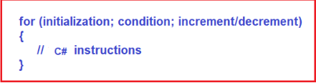

Explanation of the for-loop syntax:
Loop Initialization: Loop initialization happens only once while executing the for loop, which means that the initialization part of for loop only executes once. Here, initialization means we need to initialize the counter variable.
Condition Evaluation: Conditions in for loop are executed for each iteration and if the condition is true, it executes the C# instruction and if the condition is false then it comes out of the loop.
Execution of Instruction: Once the condition is evaluated, and if the condition is true, then the control comes to the loop body i.e. the loop body is going to be executed.
Increment/Decrement: After executing the loop body, the increment/decrement part of the for loop will be executed, and once it executes the increment decrement part i.e. once it increments and decrements the counter variable, again it will go to the condition evaluation stage.

